**Раскраска «Одежда для девочек и мальчиков дошкольного возраста»**



Гендерное воспитание – это организация условий для воспитания и развития ребёнка с учётом принадлежности к определённому полу. Пособие поможет детям сформировать представление о различиях между мальчиками и девочками не только по чертам характера и поведению, но и по внешнему виду, то есть по одежде, изучая свой гардероб.

Интернет ресурсы: [**moi-raskraski.ru**](http://www.yandex.ru/clck/jsredir?bu=4b46w2&from=www.yandex.ru%3Bsearch%2F%3Bweb%3B%3B&text=&etext=1775.alYdnYZ5VWA85iSq5c3VU6j1wSfwnylvwEcDaKMgBU8XMSdHS6EB7zAmlRd8MopZxORWNvFLS9xR_GpYBxKaIkn265JGc7GsrzPbK2PRhGY.94f8610e31767bde3dbfff18d074192405ebdacc&uuid=&state=PEtFfuTeVD4jaxywoSUvtB2i7c0_vxGdLyUleSCL07jYUobVB7X3KryVrpLc9B89z0H7qWkqyW-VyN-v70lYdNcsfkNGoRqWbcujqGjeDWgcABXMk5tS6scFGxyuQR0-&&cst=AiuY0DBWFJ5fN_r-AEszk6uVr6X0Mpulx6dTPUb_pDmR6C1lnvkXZlKqPJzlxnz50V_YMHer8zda5IFI8yDqApfopA9ipFH28SrNy2RyVAxmhKnzE_nz12zEUkGcRAhkvA4GfvNnv2ve7vdUpEJ1cRQcHTrYqhM09YOEYS53ARn-PSx-XeM_fhWRWsI4NapBktXfJ-C7Yfw6Ibz2CrptvvQ7ghgTAEDm34LnTEDNtbC7GQ5DQtejbV2sJdewfcIzz-W1Et3E-WLxiiVcuo08pH9Ry-a96un2L_lnjadTvPoH2qSdCEoim8xJ4WD2R6uUnUZHT9lNWow6Bt9fqSvXiZJbz6QGbEA6yVNoU2xkMdQLATWWEO4pfQUb9198SScfjyOjJCU7xiwTpL4JXmeG5el9XNLYK_0sKfhKvTd7RXofeuXeOr3FVWtFp4qeqlde7JvZdx_TZPhtkav1J30pgK4yTGjJuMPQbO4GUQ52UD2avhMVF_lEJ4_JLE-hIPUgR_Hhl99-2FCkJEcx8RXN0hIzyjT_uEfzy_d2_yqtnRtYqH8w6wBkln6EFRjhVZD3WQ-iEvb86k6C73imd4KVmzeSgP3xr0VIDMzq7--hyVXooL1hD-fm5F5Id4mtp4Z-nUYXdJMnKuHTJZhCokWujbWJojB3f9ywVts-wTvUdAKgWwmwbYN9KwF5VrsWCUnxSb1VR4iZmgRInf-HYqe-k1hRju9uFAhzdQZaOIdKFw7Z1EQ88jbfXY0p4FdWTeJdAGiNIt2VUj3vGz4Y57K5mBZHt_6bMcGE-BtztC6ggsJEzDd4Iv5AnHphi75L7BCWaPB6gxG1W8h12wAT9G4SubSsfE_6h6XoG-oPpgR3BwDBUrjSr_6v1N8Y4S2wAdWvcykoZGBmlVV3CZweX4i4Qtva7PLYUMQyYZCekpPbeq5uGHcz5ylZ4NNCUYp_9sqzUnO7MGQrxVPsz2L-Gjf4JEAA8l_6nz0ByzpcJYcM_iF097oa5m48P3xiZf7rEG_3SGeTnlPFVhk9vJXfby8vm5wZycx3cdx2&data=UlNrNmk5WktYejR0eWJFYk1LdmtxaHFQNjdIblE1eVk1VnlhLUFLeTlFTjVrMmZXbldIUEZXZnhXcmF2U0kyQ3c0eE1JcFZtMUV4MjJyak9yR19oVng0YTd2czBKM0RJcFN5MUZhZFpRY1ks&sign=8b2956a61c0faaa6ef82e7bd10979f47&keyno=0&b64e=2&ref=orjY4mGPRjlSKyJlbRuxUg7kv3-HD3rXBde6r9T1920,&l10n=ru&cts=1525286922039&mc=5.125178986625574), [**solkids.ru**](http://www.yandex.ru/clck/jsredir?bu=6546w2&from=www.yandex.ru%3Bsearch%2F%3Bweb%3B%3B&text=&etext=1775.alYdnYZ5VWA85iSq5c3VU6j1wSfwnylvwEcDaKMgBU8XMSdHS6EB7zAmlRd8MopZxORWNvFLS9xR_GpYBxKaIkn265JGc7GsrzPbK2PRhGY.94f8610e31767bde3dbfff18d074192405ebdacc&uuid=&state=PEtFfuTeVD4jaxywoSUvtB2i7c0_vxGd2E9eR729KuIQGpPxcKWQSHSdfi63Is_-FTQakDLX4CnzjSt-1of3FmeFR1LV402h&&cst=AiuY0DBWFJ5fN_r-AEszk6uVr6X0Mpulx6dTPUb_pDmR6C1lnvkXZlKqPJzlxnz50V_YMHer8zda5IFI8yDqApfopA9ipFH28SrNy2RyVAxmhKnzE_nz12zEUkGcRAhkvA4GfvNnv2ve7vdUpEJ1cRQcHTrYqhM09YOEYS53ARn-PSx-XeM_fhWRWsI4NapBktXfJ-C7Yfw6Ibz2CrptvvQ7ghgTAEDm34LnTEDNtbC7GQ5DQtejbV2sJdewfcIzz-W1Et3E-WLxiiVcuo08pH9Ry-a96un2L_lnjadTvPoH2qSdCEoim8xJ4WD2R6uUnUZHT9lNWow6Bt9fqSvXiZJbz6QGbEA6yVNoU2xkMdQLATWWEO4pfQUb9198SScfjyOjJCU7xiwTpL4JXmeG5el9XNLYK_0sKfhKvTd7RXofeuXeOr3FVWtFp4qeqlde7JvZdx_TZPhtkav1J30pgK4yTGjJuMPQbO4GUQ52UD2avhMVF_lEJ4_JLE-hIPUgR_Hhl99-2FCkJEcx8RXN0hIzyjT_uEfzy_d2_yqtnRtYqH8w6wBkln6EFRjhVZD3WQ-iEvb86k6C73imd4KVmzeSgP3xr0VIDMzq7--hyVXooL1hD-fm5F5Id4mtp4Z-nUYXdJMnKuHTJZhCokWujbWJojB3f9ywVts-wTvUdAKgWwmwbYN9KwF5VrsWCUnxSb1VR4iZmgRInf-HYqe-k1hRju9uFAhzdQZaOIdKFw7Z1EQ88jbfXY0p4FdWTeJdAGiNIt2VUj3vGz4Y57K5mBZHt_6bMcGE-BtztC6ggsJEzDd4Iv5AnHphi75L7BCWaPB6gxG1W8h12wAT9G4SubSsfE_6h6XoG-oPpgR3BwDBUrjSr_6v1N8Y4S2wAdWvcykoZGBmlVV3CZweX4i4Qtva7PLYUMQyYZCekpPbeq5uGHcz5ylZ4NNCUYp_9sqzUnO7MGQrxVPsz2L-Gjf4JEAA8l_6nz0ByzpcJYcM_iF097oa5m48P3xiZf7rEG_3SGeTnlPFVhk9vJXfby8vm5wZycx3cdx2&data=UlNrNmk5WktYejR0eWJFYk1LdmtxcjRQeFo0cHpHSEtMUU5QdVJaTTF1YnRNVTFweUFNb2ttSUR6MW10T0dvTGYtbjVOWE5aZ0xoc2l6OUcxUTRkdndYbGhuZnI2NjdM&sign=93dcbc17f11d6f0d9a5718280742bf58&keyno=0&b64e=2&ref=orjY4mGPRjlSKyJlbRuxUg7kv3-HD3rXBde6r9T1920,&l10n=ru&cts=1525287088978&mc=5.193685029456633)›[interesnye-raskraski/632-raskraska…dla…](http://www.solkids.ru/interesnye-raskraski/632-raskraska-odejda-dla-detey-raspec)

[**auho.ru**](http://www.yandex.ru/clck/jsredir?bu=5f46w2&from=www.yandex.ru%3Bsearch%2F%3Bweb%3B%3B&text=&etext=1775.alYdnYZ5VWA85iSq5c3VU6j1wSfwnylvwEcDaKMgBU8XMSdHS6EB7zAmlRd8MopZxORWNvFLS9xR_GpYBxKaIkn265JGc7GsrzPbK2PRhGY.94f8610e31767bde3dbfff18d074192405ebdacc&uuid=&state=PEtFfuTeVD4jaxywoSUvtB2i7c0_vxGd2E9eR729KuIQGpPxcKWQSHSdfi63Is_-FTQakDLX4Cmc-B9SGBtn3LgBdOC4dBCg&&cst=AiuY0DBWFJ5fN_r-AEszk6uVr6X0Mpulx6dTPUb_pDmR6C1lnvkXZlKqPJzlxnz50V_YMHer8zda5IFI8yDqApfopA9ipFH28SrNy2RyVAxmhKnzE_nz12zEUkGcRAhkvA4GfvNnv2ve7vdUpEJ1cRQcHTrYqhM09YOEYS53ARn-PSx-XeM_fhWRWsI4NapBktXfJ-C7Yfw6Ibz2CrptvvQ7ghgTAEDm34LnTEDNtbC7GQ5DQtejbV2sJdewfcIzz-W1Et3E-WLxiiVcuo08pH9Ry-a96un2L_lnjadTvPoH2qSdCEoim8xJ4WD2R6uUnUZHT9lNWow6Bt9fqSvXiZJbz6QGbEA6yVNoU2xkMdQLATWWEO4pfQUb9198SScfjyOjJCU7xiwTpL4JXmeG5el9XNLYK_0sKfhKvTd7RXofeuXeOr3FVWtFp4qeqlde7JvZdx_TZPhtkav1J30pgK4yTGjJuMPQbO4GUQ52UD2avhMVF_lEJ4_JLE-hIPUgR_Hhl99-2FCkJEcx8RXN0hIzyjT_uEfzy_d2_yqtnRtYqH8w6wBkln6EFRjhVZD3WQ-iEvb86k6C73imd4KVmzeSgP3xr0VIDMzq7--hyVXooL1hD-fm5F5Id4mtp4Z-nUYXdJMnKuHTJZhCokWujbWJojB3f9ywVts-wTvUdAKgWwmwbYN9KwF5VrsWCUnxSb1VR4iZmgRInf-HYqe-k1hRju9uFAhzdQZaOIdKFw7Z1EQ88jbfXY0p4FdWTeJdAGiNIt2VUj3vGz4Y57K5mBZHt_6bMcGE-BtztC6ggsJEzDd4Iv5AnHphi75L7BCWaPB6gxG1W8h12wAT9G4SubSsfE_6h6XoG-oPpgR3BwDBUrjSr_6v1N8Y4S2wAdWvcykoZGBmlVV3CZweX4i4Qtva7PLYUMQyYZCekpPbeq5uGHcz5ylZ4NNCUYp_9sqzUnO7MGQrxVPsz2L-Gjf4JEAA8l_6nz0ByzpcJYcM_iF097oa5m48P3xiZf7rEG_3SGeTnlPFVhk9vJXfby8vm5wZycx3cdx2&data=UlNrNmk5WktYejR0eWJFYk1LdmtxcmRPU2FxcGgxa2YyMWdMS2VQcnNBOU5JNkRVVWl6UGwyWGJzVVBCQ1JVdW05T0xSdkxidWRhTUpyTnFkQ0V6VEEsLA,,&sign=52cfa2115fae3b212ee0a45a49544715&keyno=0&b64e=2&ref=orjY4mGPRjlSKyJlbRuxUg7kv3-HD3rXBde6r9T1920,&l10n=ru&cts=1525287016055&mc=5.194886181861278)›[Интересные раскраски](http://www.yandex.ru/clck/jsredir?bu=5g46w2&from=www.yandex.ru%3Bsearch%2F%3Bweb%3B%3B&text=&etext=1775.alYdnYZ5VWA85iSq5c3VU6j1wSfwnylvwEcDaKMgBU8XMSdHS6EB7zAmlRd8MopZxORWNvFLS9xR_GpYBxKaIkn265JGc7GsrzPbK2PRhGY.94f8610e31767bde3dbfff18d074192405ebdacc&uuid=&state=PEtFfuTeVD4jaxywoSUvtB2i7c0_vxGd2E9eR729KuIQGpPxcKWQSHSdfi63Is_-DnbKz8oeZi1k_ZcZDL25R4k_r_oA_9fq&&cst=AiuY0DBWFJ5fN_r-AEszk6uVr6X0Mpulx6dTPUb_pDmR6C1lnvkXZlKqPJzlxnz50V_YMHer8zda5IFI8yDqApfopA9ipFH28SrNy2RyVAxmhKnzE_nz12zEUkGcRAhkvA4GfvNnv2ve7vdUpEJ1cRQcHTrYqhM09YOEYS53ARn-PSx-XeM_fhWRWsI4NapBktXfJ-C7Yfw6Ibz2CrptvvQ7ghgTAEDm34LnTEDNtbC7GQ5DQtejbV2sJdewfcIzz-W1Et3E-WLxiiVcuo08pH9Ry-a96un2L_lnjadTvPoH2qSdCEoim8xJ4WD2R6uUnUZHT9lNWow6Bt9fqSvXiZJbz6QGbEA6yVNoU2xkMdQLATWWEO4pfQUb9198SScfjyOjJCU7xiwTpL4JXmeG5el9XNLYK_0sKfhKvTd7RXofeuXeOr3FVWtFp4qeqlde7JvZdx_TZPhtkav1J30pgK4yTGjJuMPQbO4GUQ52UD2avhMVF_lEJ4_JLE-hIPUgR_Hhl99-2FCkJEcx8RXN0hIzyjT_uEfzy_d2_yqtnRtYqH8w6wBkln6EFRjhVZD3WQ-iEvb86k6C73imd4KVmzeSgP3xr0VIDMzq7--hyVXooL1hD-fm5F5Id4mtp4Z-nUYXdJMnKuHTJZhCokWujbWJojB3f9ywVts-wTvUdAKgWwmwbYN9KwF5VrsWCUnxSb1VR4iZmgRInf-HYqe-k1hRju9uFAhzdQZaOIdKFw7Z1EQ88jbfXY0p4FdWTeJdAGiNIt2VUj3vGz4Y57K5mBZHt_6bMcGE-BtztC6ggsJEzDd4Iv5AnHphi75L7BCWaPB6gxG1W8h12wAT9G4SubSsfE_6h6XoG-oPpgR3BwDBUrjSr_6v1N8Y4S2wAdWvcykoZGBmlVV3CZweX4i4Qtva7PLYUMQyYZCekpPbeq5uGHcz5ylZ4NNCUYp_9sqzUnO7MGQrxVPsz2L-Gjf4JEAA8l_6nz0ByzpcJYcM_iF097oa5m48P3xiZf7rEG_3SGeTnlPFVhk9vJXfby8vm5wZycx3cdx2&data=UlNrNmk5WktYejR0eWJFYk1LdmtxcmRPU2FxcGgxa2ZRYUNoOC1Nd0p3RGM4UlJ5NnBObjFmcTZyWVNCRU9UbEVhWGFLN0REOVhNWGp3OVV5d2FOUlpwVHlkUzl1MFh4WDVQSW9teF80YWdmOXQzdHdxOG80QSws&sign=9a8d33e7dff8446fe6ba727708ef85c5&keyno=0&b64e=2&ref=orjY4mGPRjlSKyJlbRuxUg7kv3-HD3rXBde6r9T1920,&l10n=ru&cts=1525287010119&mc=5.189588593815939), [**detskie-raskraski.ru**](http://www.yandex.ru/clck/jsredir?bu=7546w2&from=www.yandex.ru%3Bsearch%2F%3Bweb%3B%3B&text=&etext=1775.alYdnYZ5VWA85iSq5c3VU6j1wSfwnylvwEcDaKMgBU8XMSdHS6EB7zAmlRd8MopZxORWNvFLS9xR_GpYBxKaIkn265JGc7GsrzPbK2PRhGY.94f8610e31767bde3dbfff18d074192405ebdacc&uuid=&state=PEtFfuTeVD4jaxywoSUvtB2i7c0_vxGdLyUleSCL07jYUobVB7X3KryVrpLc9B89z0H7qWkqyW-VyN-v70lYdNcsfkNGoRqWKwXuXazfD2uBlagUUSno-jMiSfsqC3E-&&cst=AiuY0DBWFJ5fN_r-AEszk6uVr6X0Mpulx6dTPUb_pDmR6C1lnvkXZlKqPJzlxnz50V_YMHer8zda5IFI8yDqApfopA9ipFH28SrNy2RyVAxmhKnzE_nz12zEUkGcRAhkvA4GfvNnv2ve7vdUpEJ1cRQcHTrYqhM09YOEYS53ARn-PSx-XeM_fhWRWsI4NapBktXfJ-C7Yfw6Ibz2CrptvvQ7ghgTAEDm34LnTEDNtbC7GQ5DQtejbV2sJdewfcIzz-W1Et3E-WLxiiVcuo08pH9Ry-a96un2L_lnjadTvPoH2qSdCEoim8xJ4WD2R6uUnUZHT9lNWow6Bt9fqSvXiZJbz6QGbEA6yVNoU2xkMdQLATWWEO4pfQUb9198SScfjyOjJCU7xiwTpL4JXmeG5el9XNLYK_0sKfhKvTd7RXofeuXeOr3FVWtFp4qeqlde7JvZdx_TZPhtkav1J30pgK4yTGjJuMPQbO4GUQ52UD2avhMVF_lEJ4_JLE-hIPUgR_Hhl99-2FCkJEcx8RXN0hIzyjT_uEfzy_d2_yqtnRtYqH8w6wBkln6EFRjhVZD3WQ-iEvb86k6C73imd4KVmzeSgP3xr0VIDMzq7--hyVXooL1hD-fm5F5Id4mtp4Z-nUYXdJMnKuHTJZhCokWujbWJojB3f9ywVts-wTvUdAKgWwmwbYN9KwF5VrsWCUnxSb1VR4iZmgRInf-HYqe-k1hRju9uFAhzdQZaOIdKFw7Z1EQ88jbfXY0p4FdWTeJdAGiNIt2VUj3vGz4Y57K5mBZHt_6bMcGE-BtztC6ggsJEzDd4Iv5AnHphi75L7BCWaPB6gxG1W8h12wAT9G4SubSsfE_6h6XoG-oPpgR3BwDBUrjSr_6v1N8Y4S2wAdWvcykoZGBmlVV3CZweX4i4Qtva7PLYUMQyYZCekpPbeq5uGHcz5ylZ4NNCUYp_9sqzUnO7MGQrxVPsz2L-Gjf4JEAA8l_6nz0ByzpcJYcM_iF097oa5m48P3xiZf7rEG_3SGeTnlPFVhk9vJXfby8vm5wZycx3cdx2&data=UlNrNmk5WktYejR0eWJFYk1LdmtxcGhQX0gzRzhWUHJWU05lSjJ0SGRCZzNYZEdCZzBaMTBTT1B1c3FfRTNSNDVESE1icWpyREFNa1FKcUExR0swV3dyM2FuU2QwclVfS2FDMVZYd1dHdjAs&sign=d52c16e66cb42e28ba7ee2d5ece35cf5&keyno=0&b64e=2&ref=orjY4mGPRjlSKyJlbRuxUg7kv3-HD3rXBde6r9T1920,&l10n=ru&cts=1525287151645&mc=5.308069856426029)›[detskie-raskraski/raskraska…](http://detskie-raskraski.ru/detskie-raskraski/raskraska-odezhda)

**Составитель**: Абросимова Надежда Петровна, воспитатель МАДОУ ЦРР – детский сад, г. Красноуфимск

**ОДЕЖДА ДЛЯ ДЕВОЧЕК**



**ШЛЯПА**

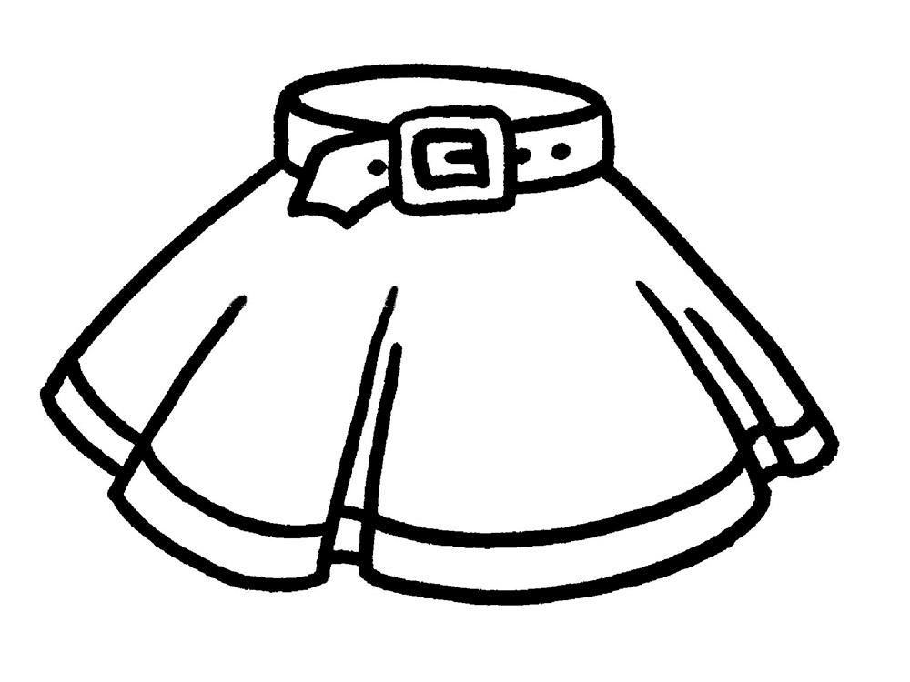**ЮБКА**

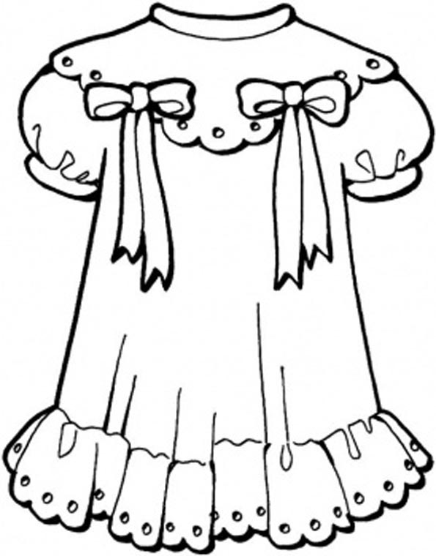

**ПЛАТЬЕ**

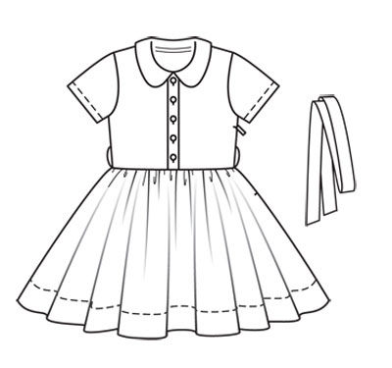

**ПЛАТЬЕ**

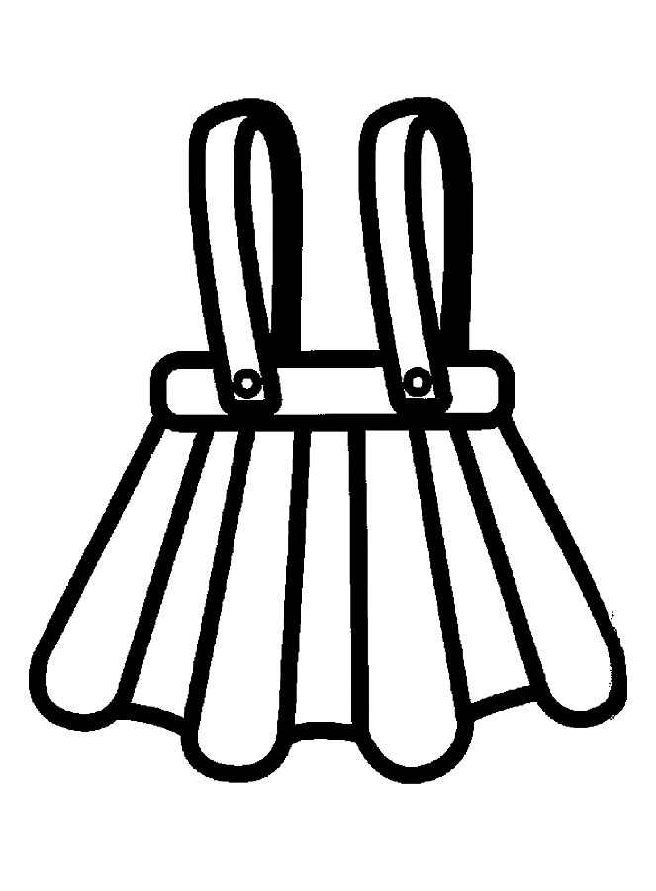

**САРАФАН**

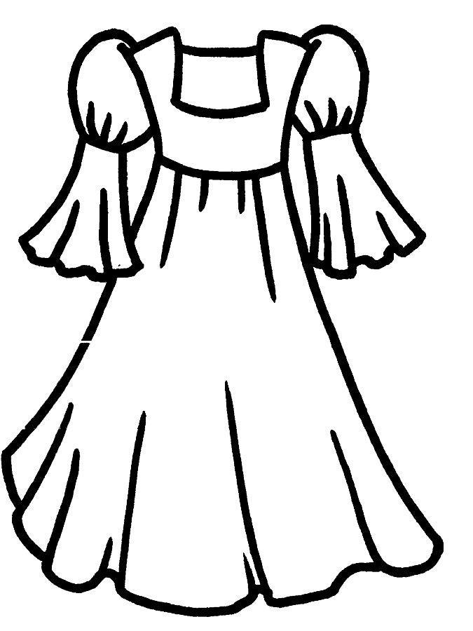

**ПЛАТЬЕ**

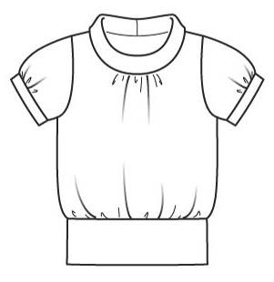

**БЛУЗКА**

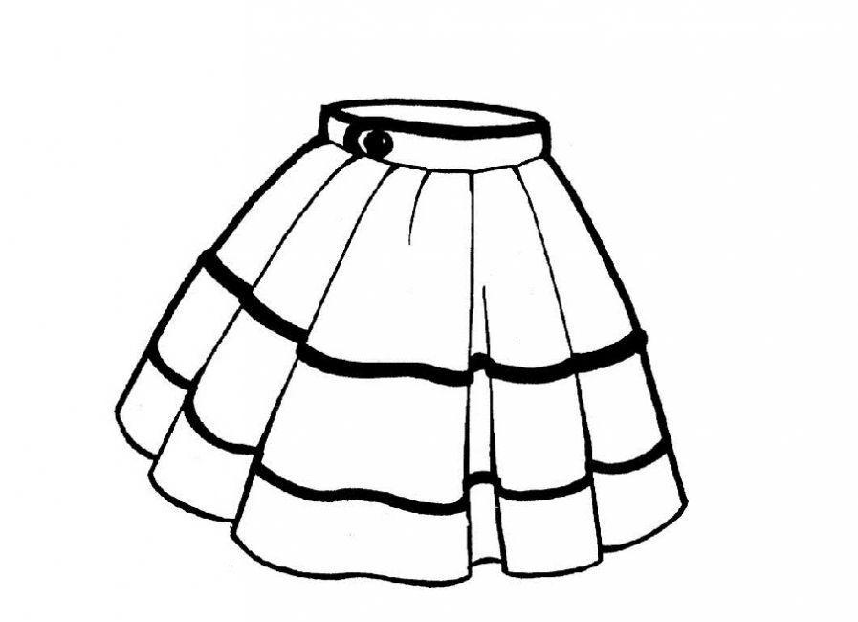

**ЮБКА**

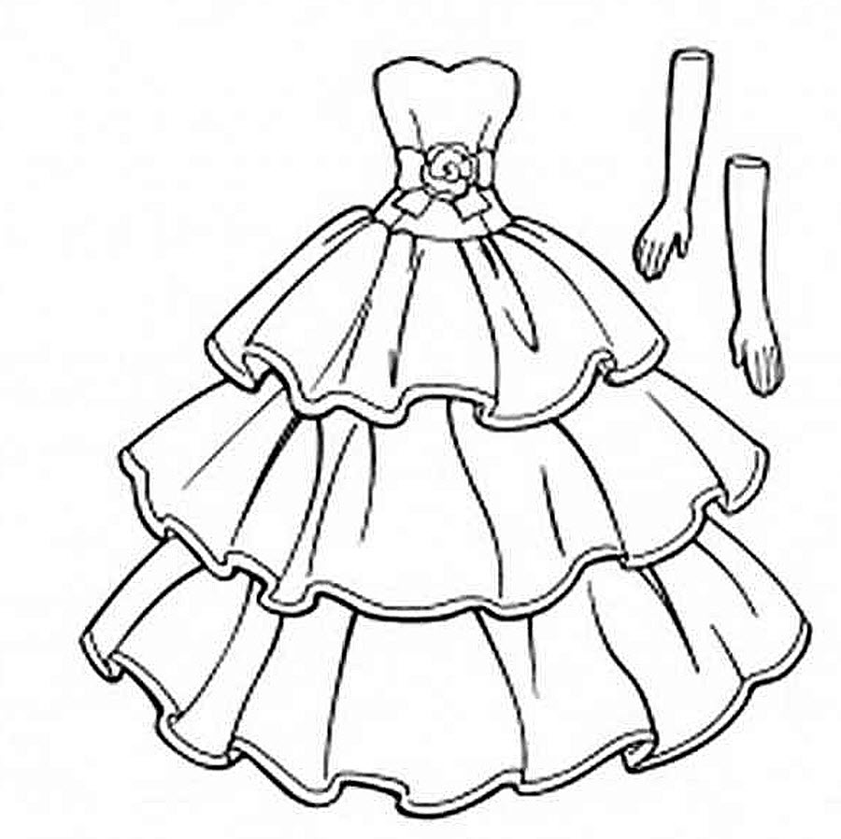

**БАЛЬНОЕ ПЛАТЬЕ**

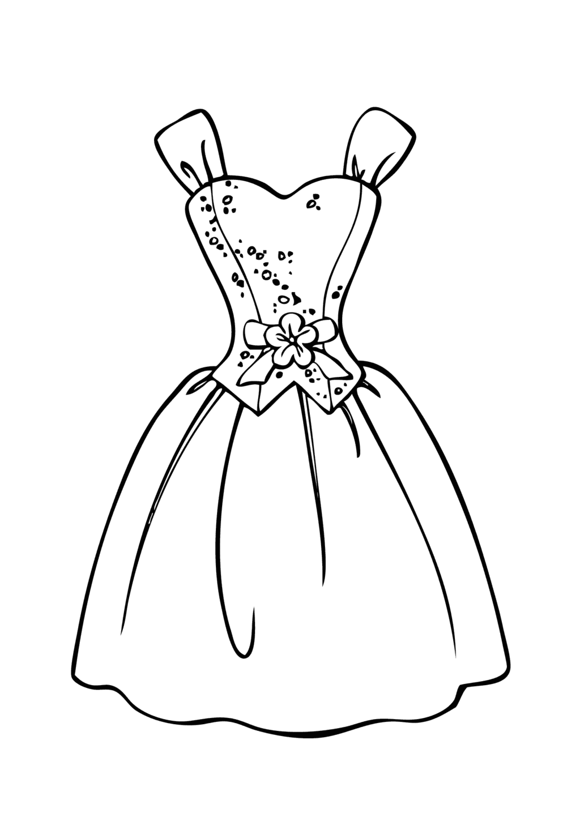

**ПЛАТЬЕ**

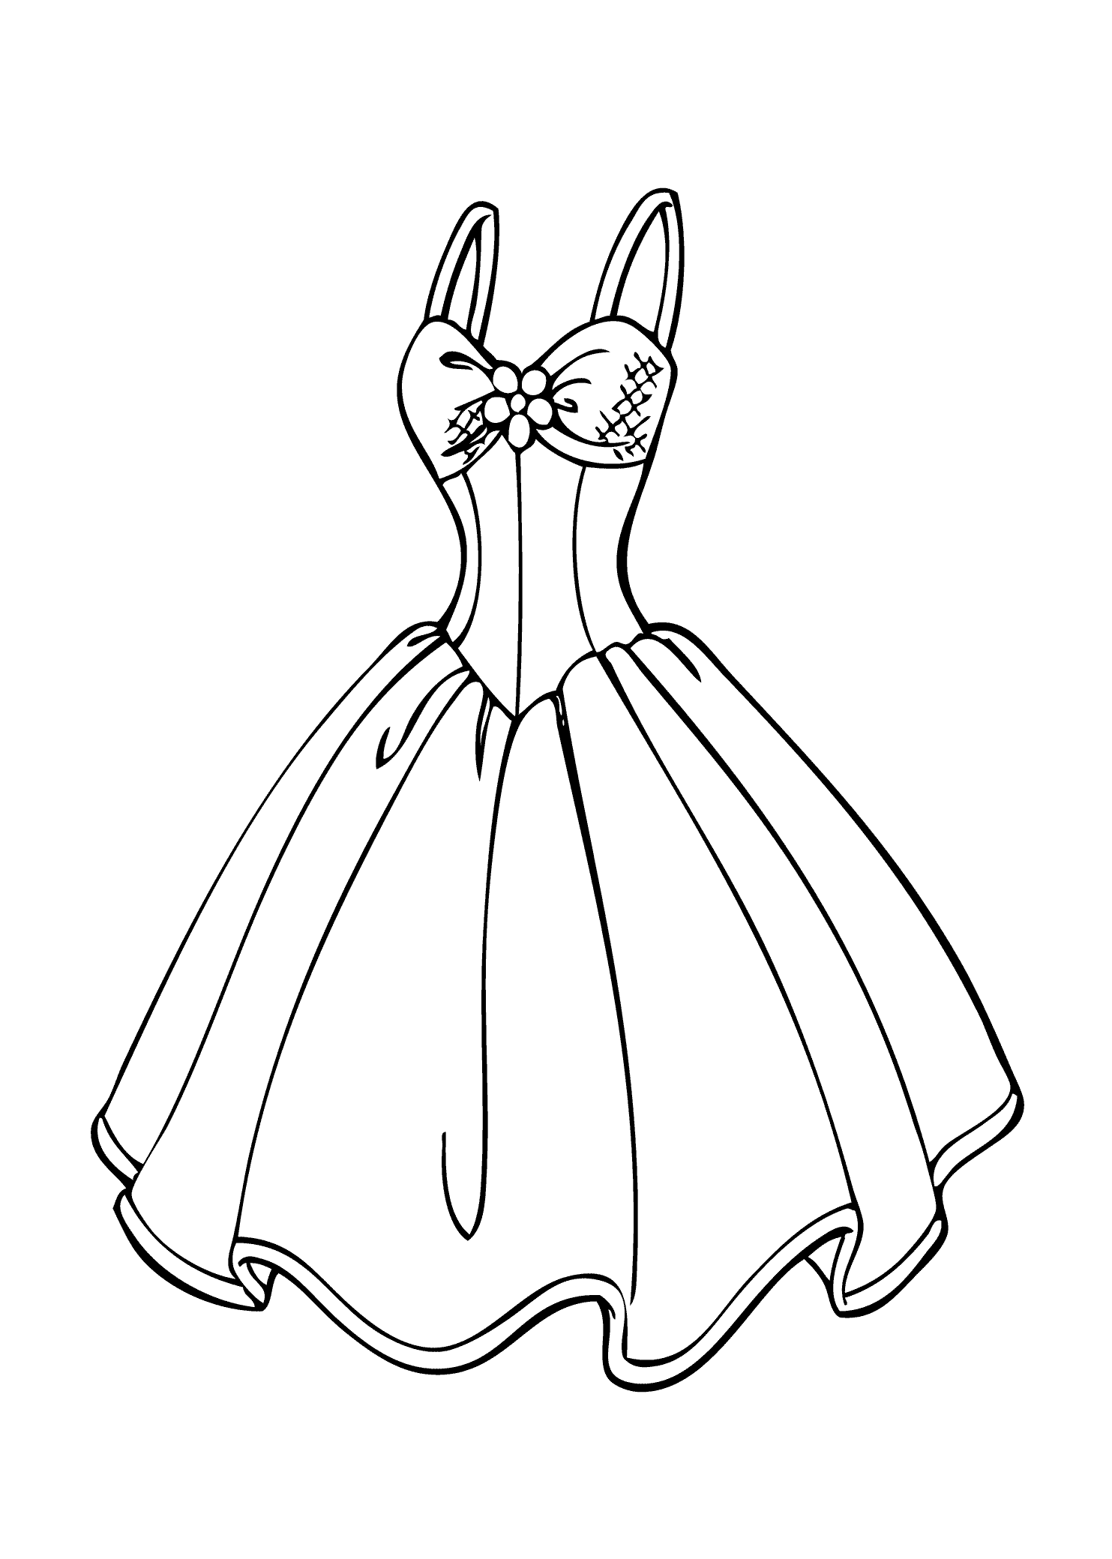

**САРАФАН**

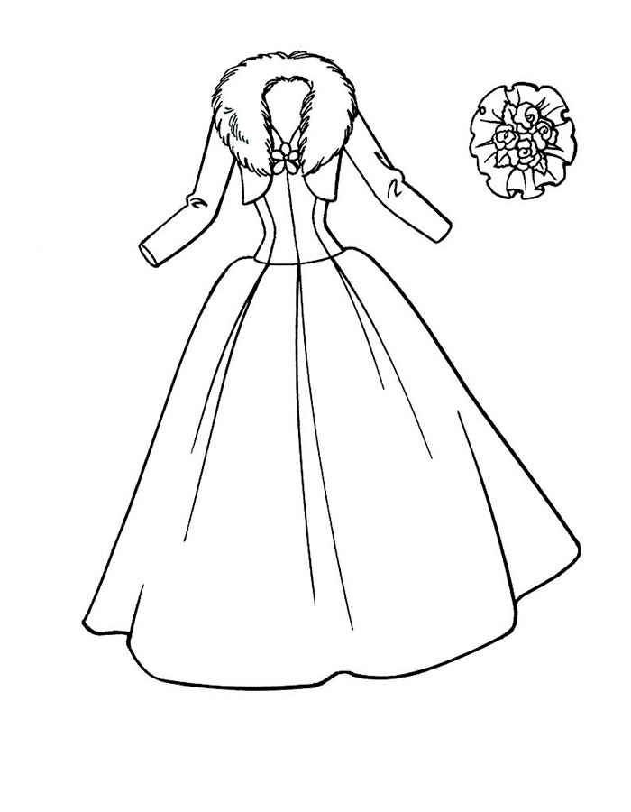

**ПЛАТЬЕ**

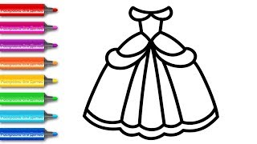

**ПЛАТЬЕ**

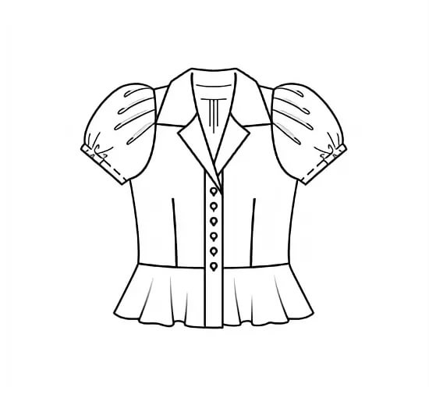

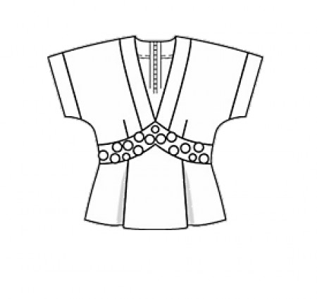

**БЛУЗКИ**

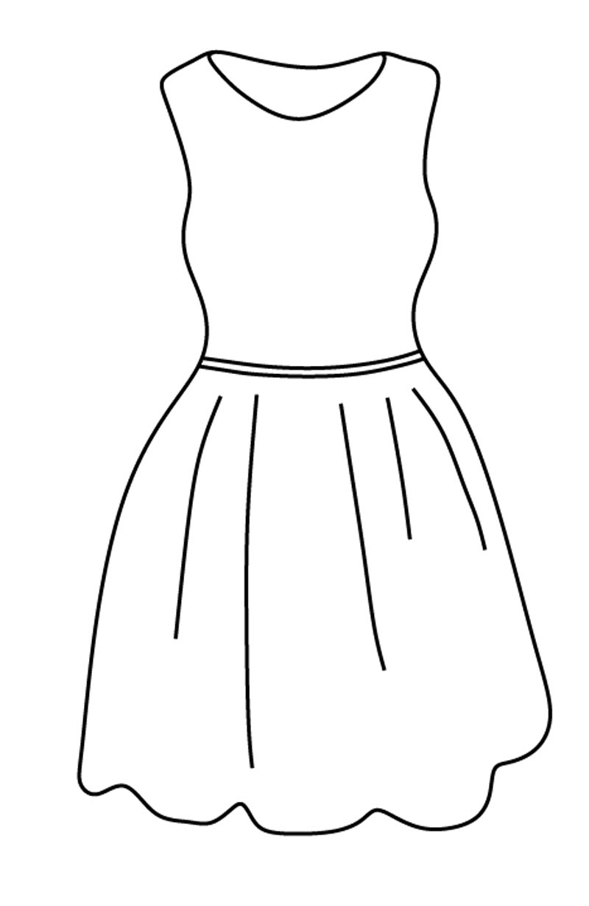

**ПЛАТЬЕ**

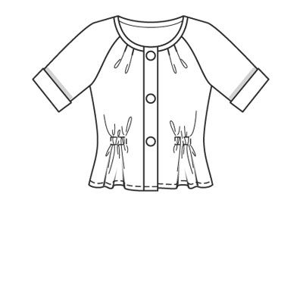

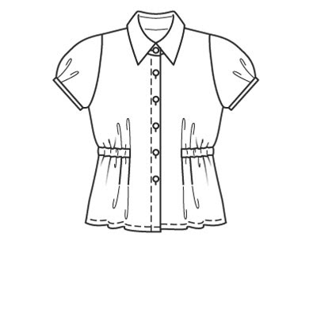

**БЛУЗКИ**

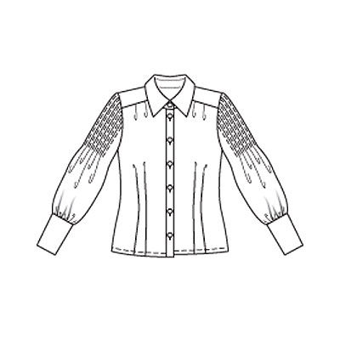

**БЛУЗКА**

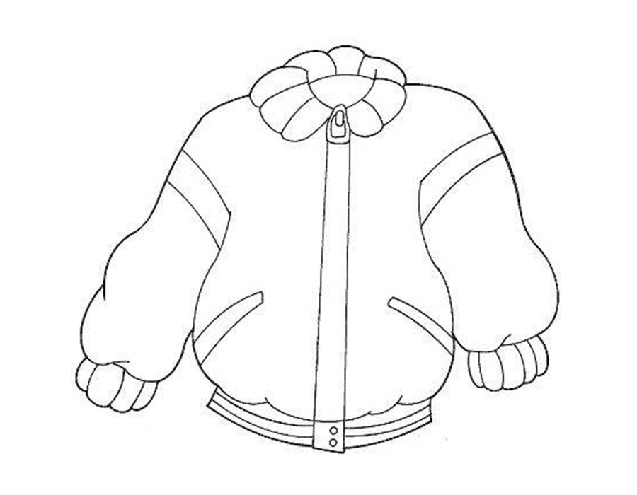

**КУРТКА**

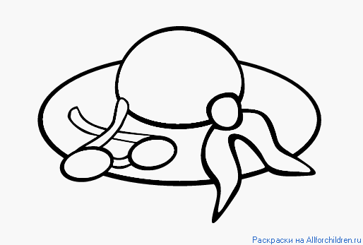

**ШЛЯПА**

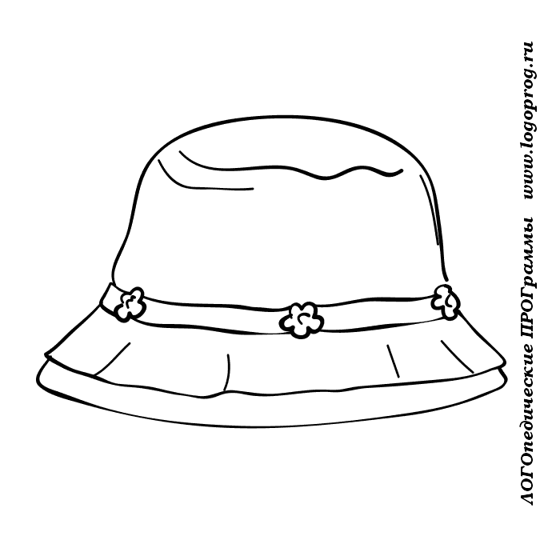

**ПАНАМА**

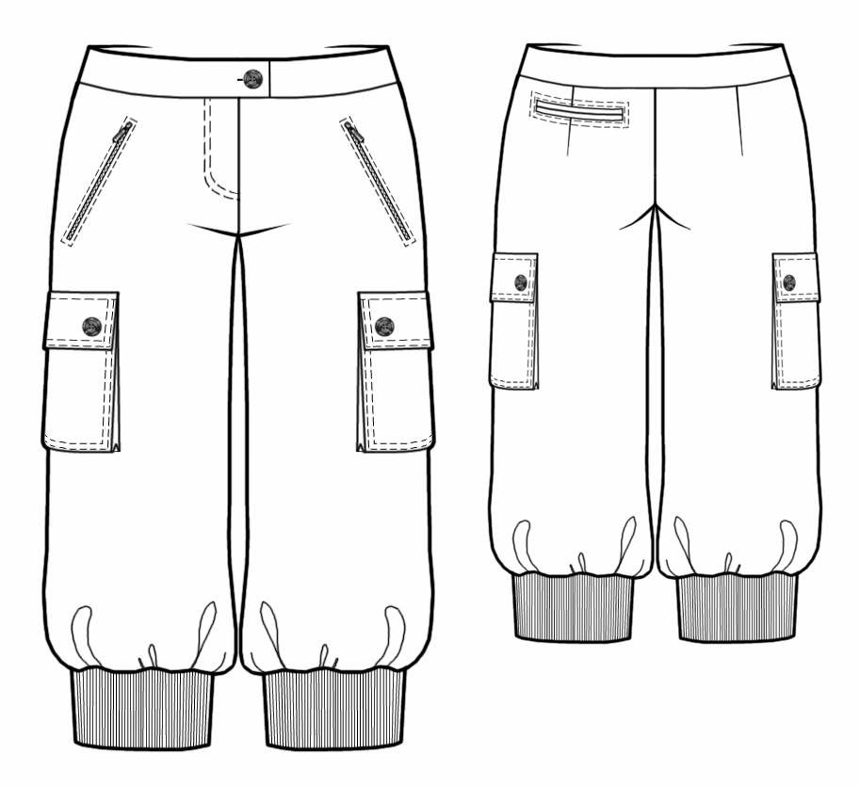

**БРЮКИ**

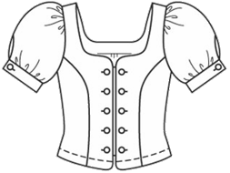

**БЛУЗКА**

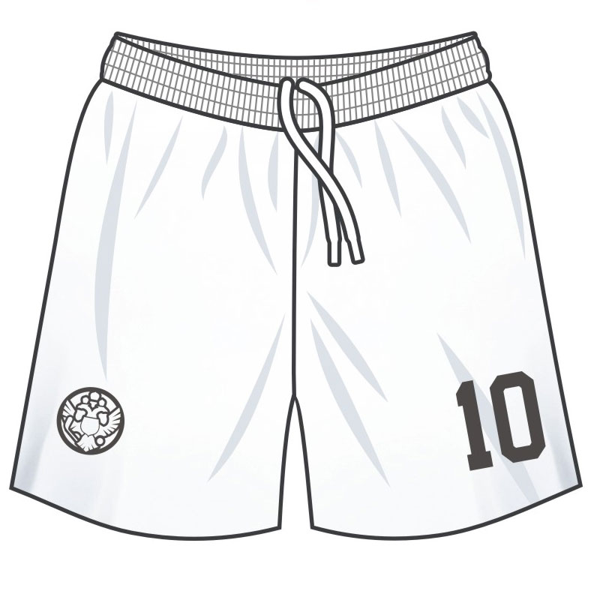

**ШОРТЫ**

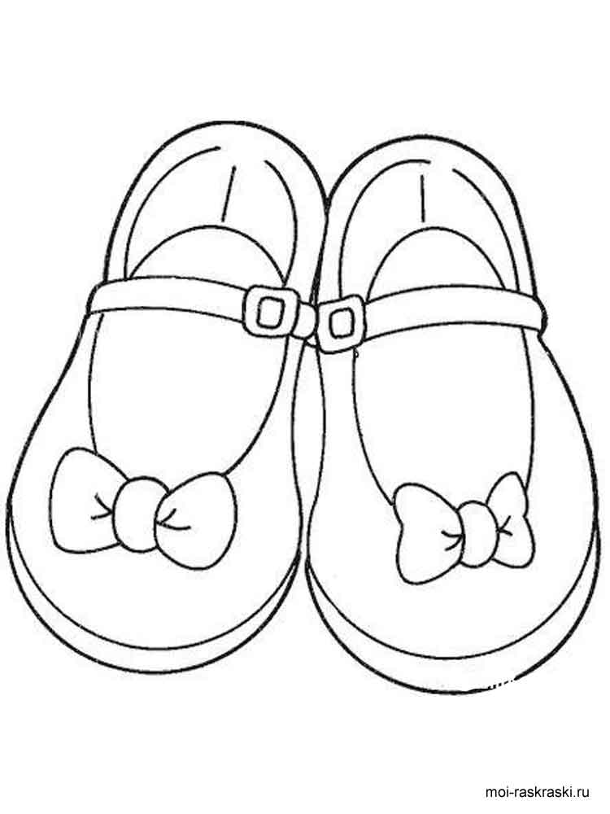

**ТУФЛИ**

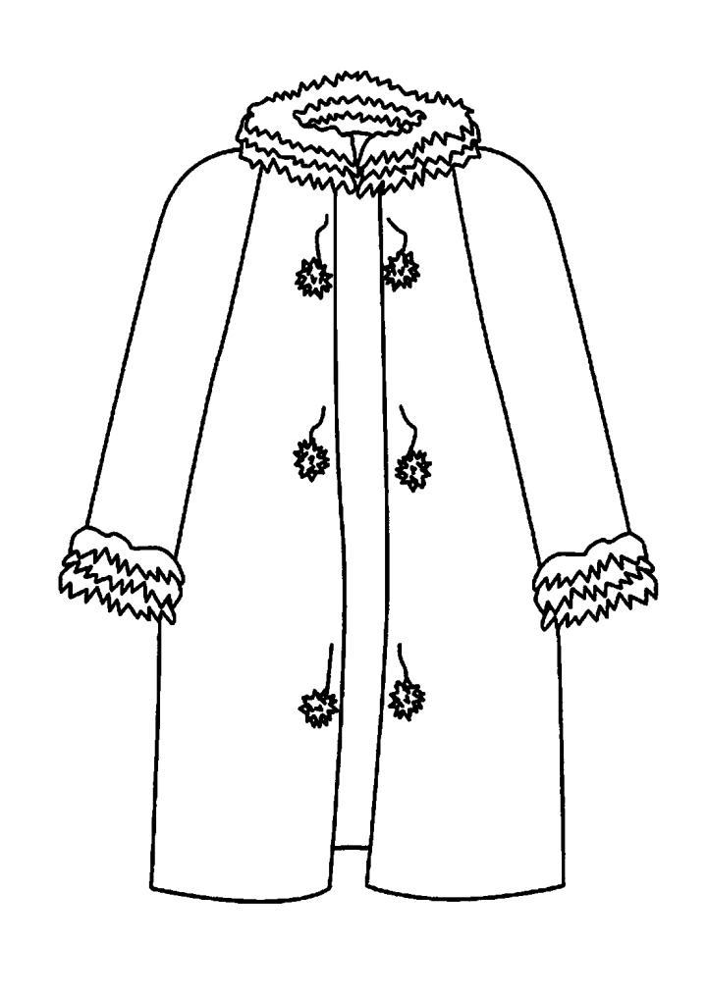

**ПАЛЬТО**

**ОДЕЖДА ДЛЯ МАЛЬЧИКОВ**

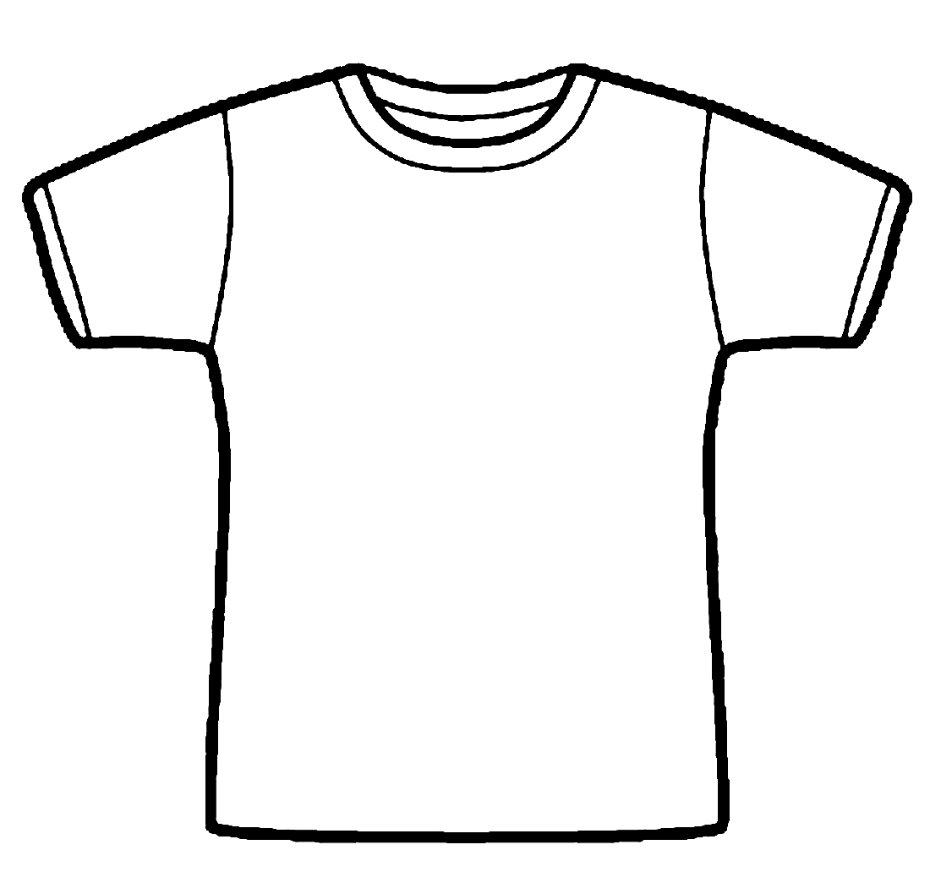

**ФУТБОЛКА**

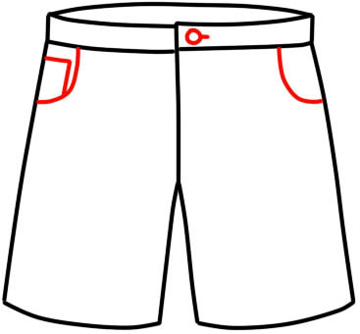

**ШОРТЫ**

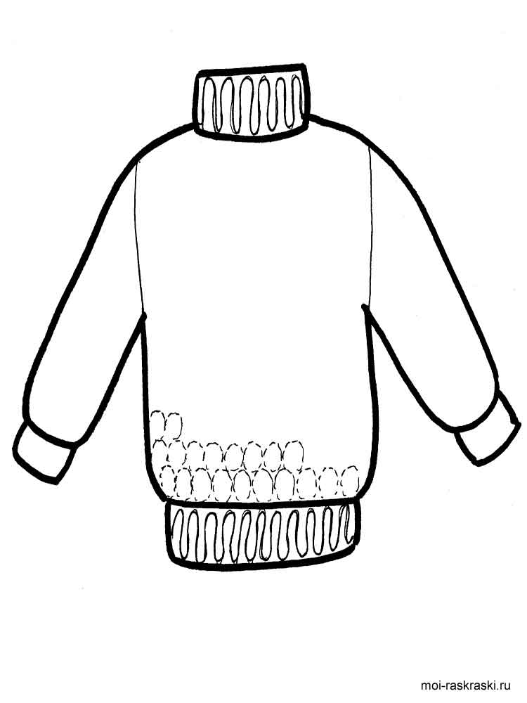

**СВИТЕР**



**ШОРТЫ**

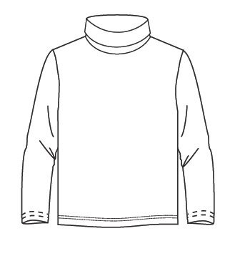

**ТОЛСТОВКА**

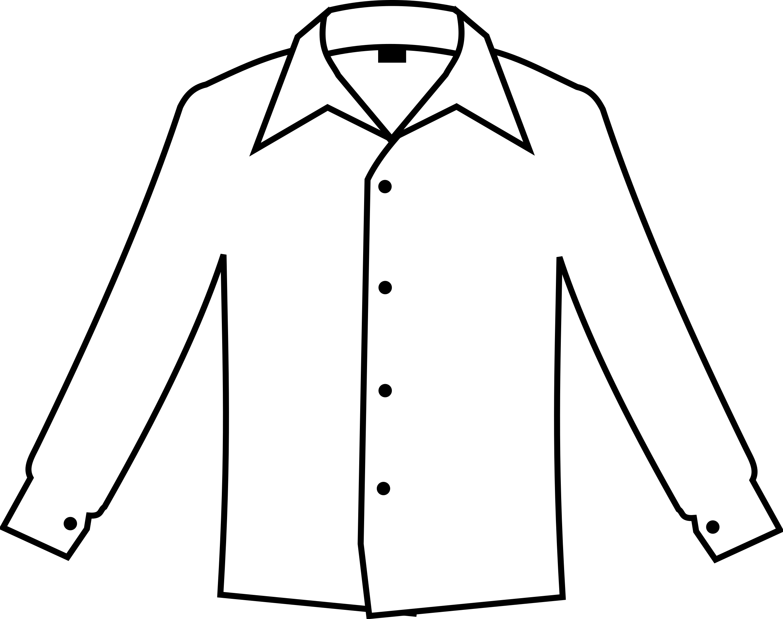

**РУБАШКА**

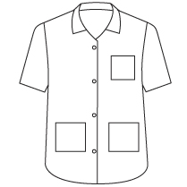

**РУБАШКА**

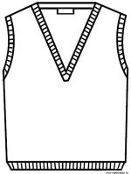

**ПОЛУВЕР**

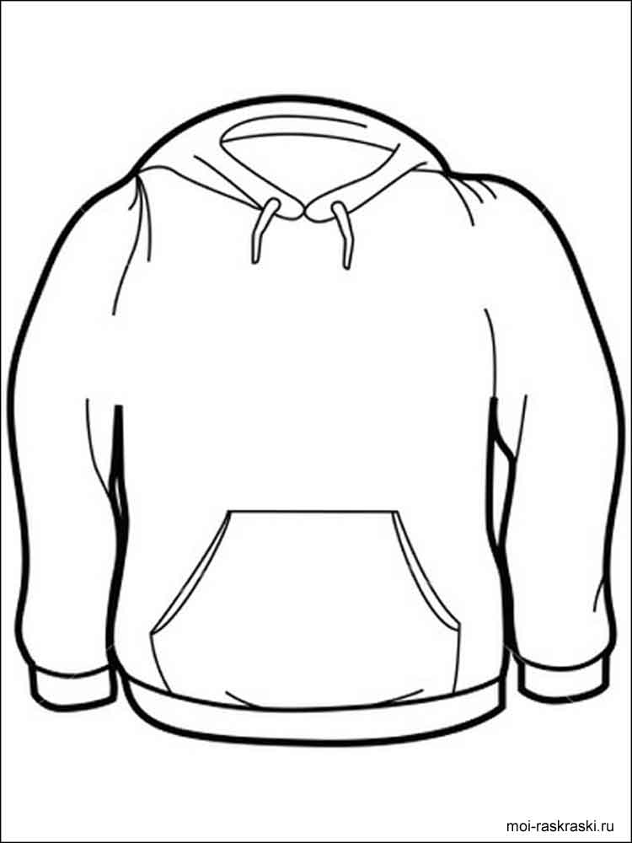

**ТОЛСТОВКА**

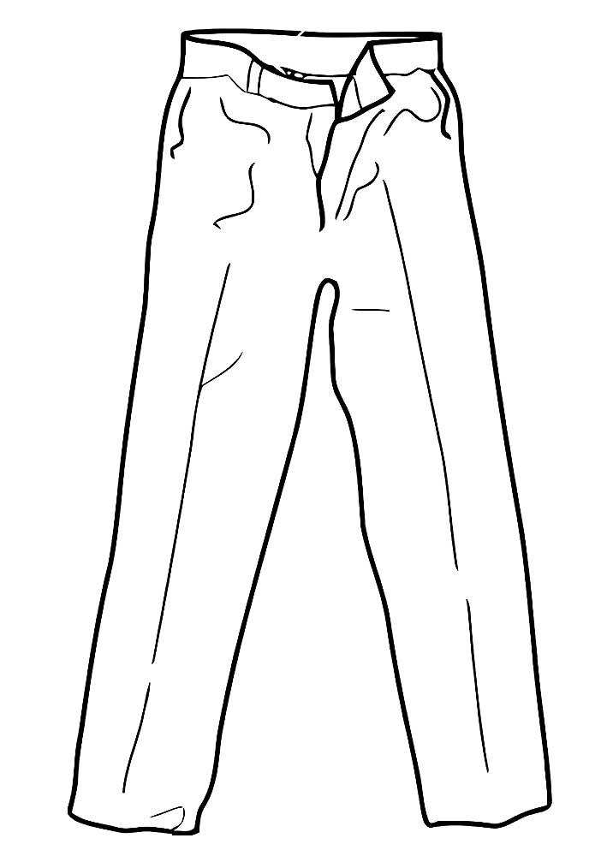

**БРЮКИ**

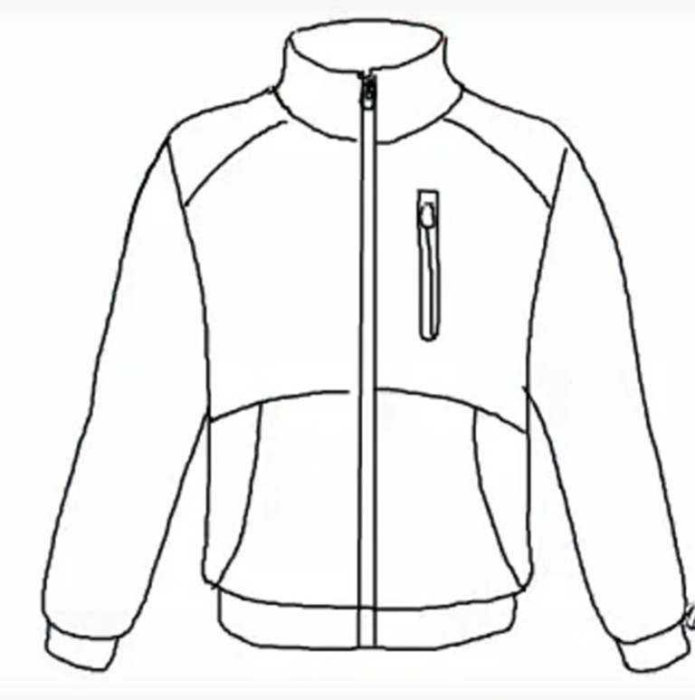

**КУРТКА**

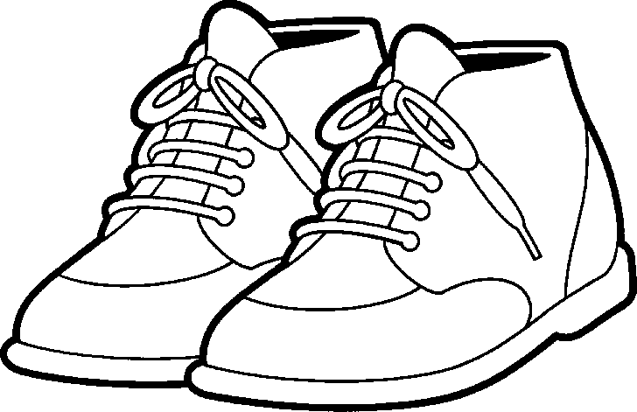

**БОТИНКИ**

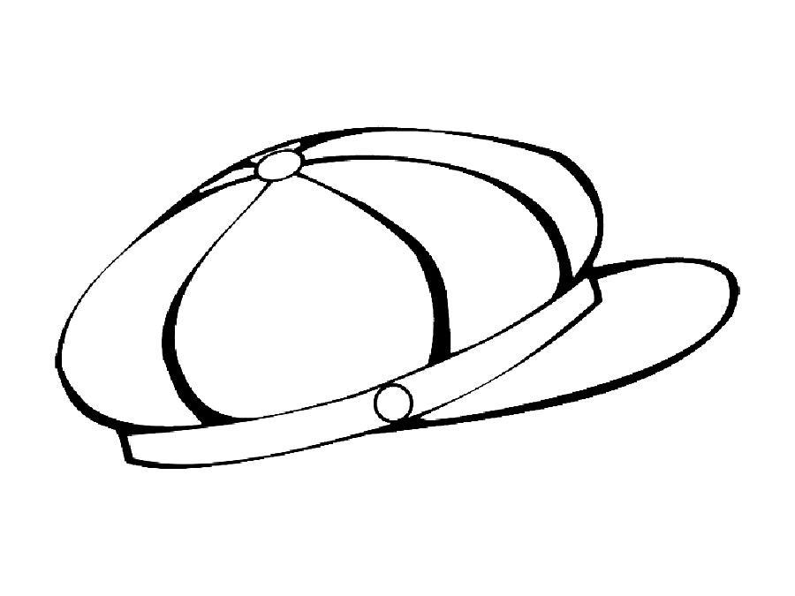

**ГОЛОВНЫЕ УБОРЫ**